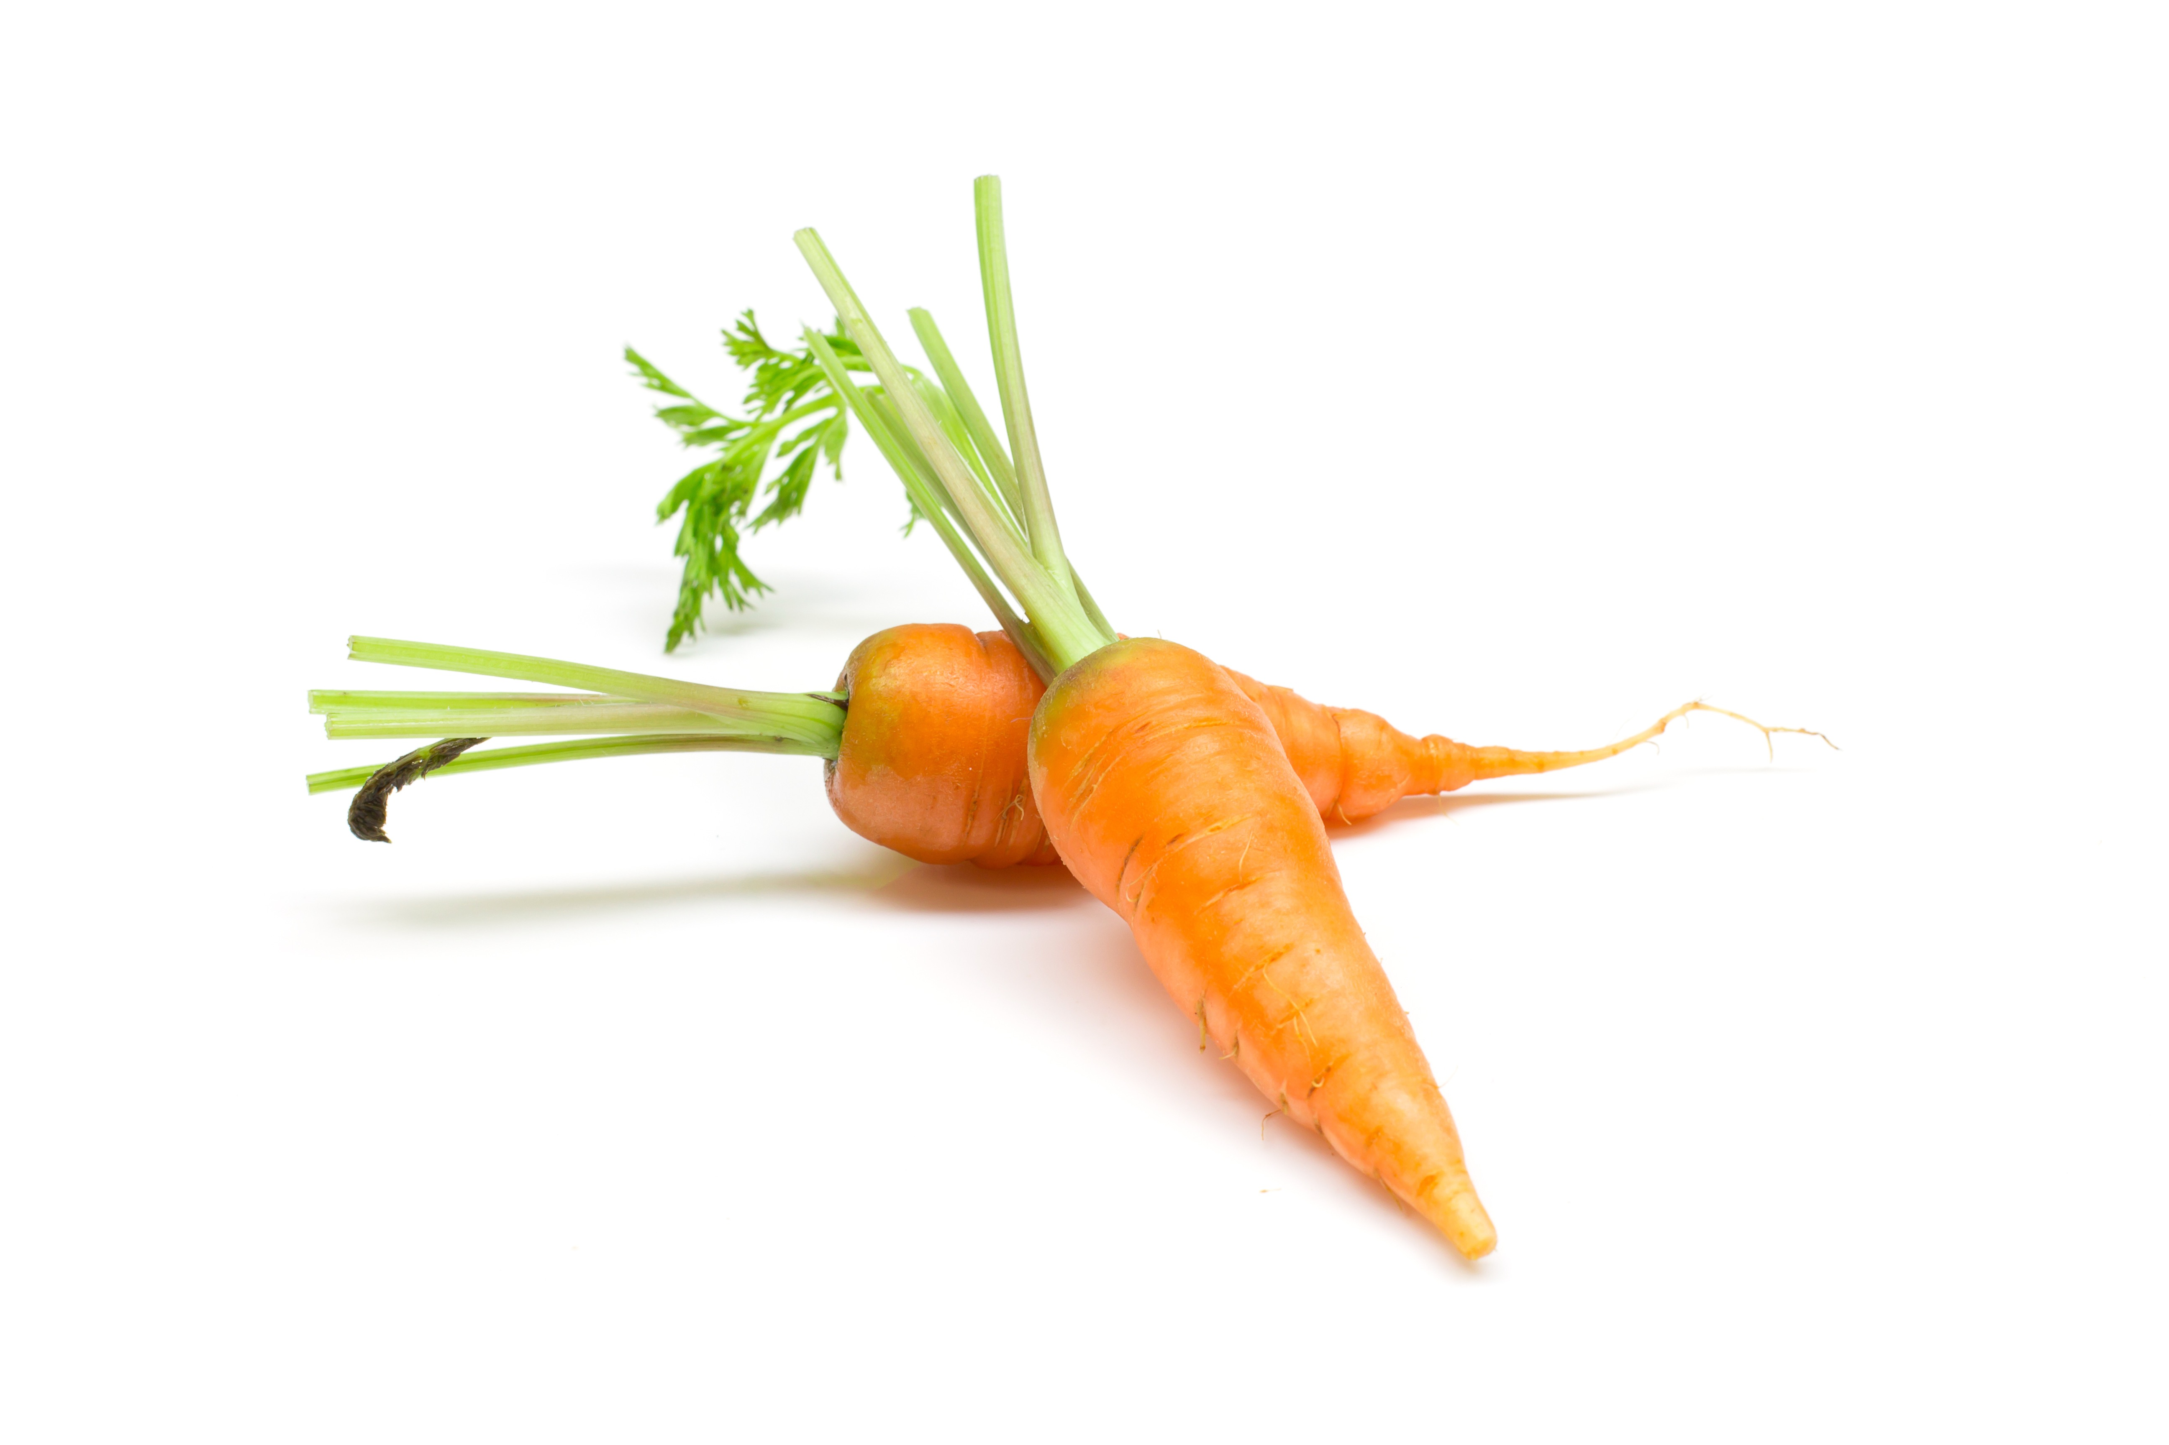

Decision making: pro and con list for 2 choices

Name: Date: Title/Issue:

CHOICE | PROS | CONS

